*Satellite mobile phone RF/IF black diagram

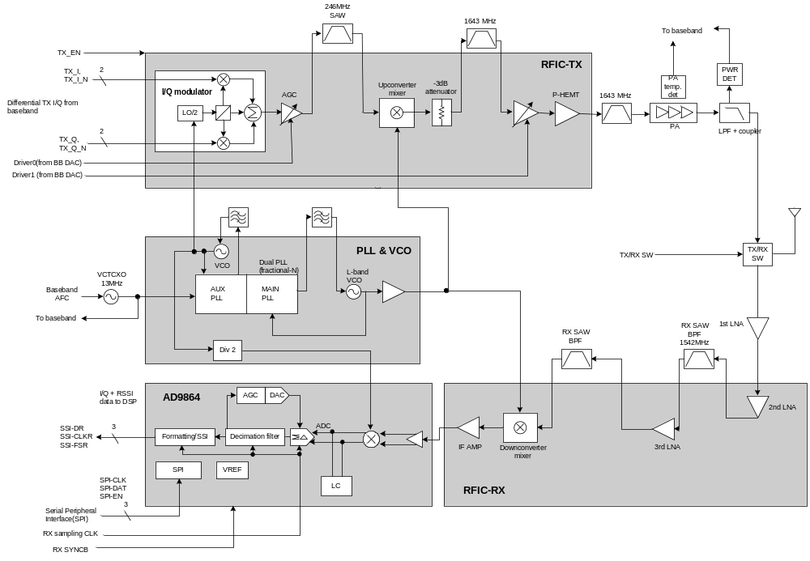
☞ Our client ask if it is possible to make above 4 kind of blocks into 1 or 2 chip.

